Building Holes for Heat-Set Inserts

At our robot team meeting I showed the heat-set inserts and described how to use them. I wanted to give some more details in this white paper.

The following is cut out from the pdf of the part from the McMaster-Carr web site, that link is: https://www.mcmaster.com/heat-set-inserts. Not shown on this diagram but from the McMaster-Carr web site the ¼ inserts are for a maximum hole diameter of 0.316. This is the size I’ve been using for my plastic parts and is working very well.

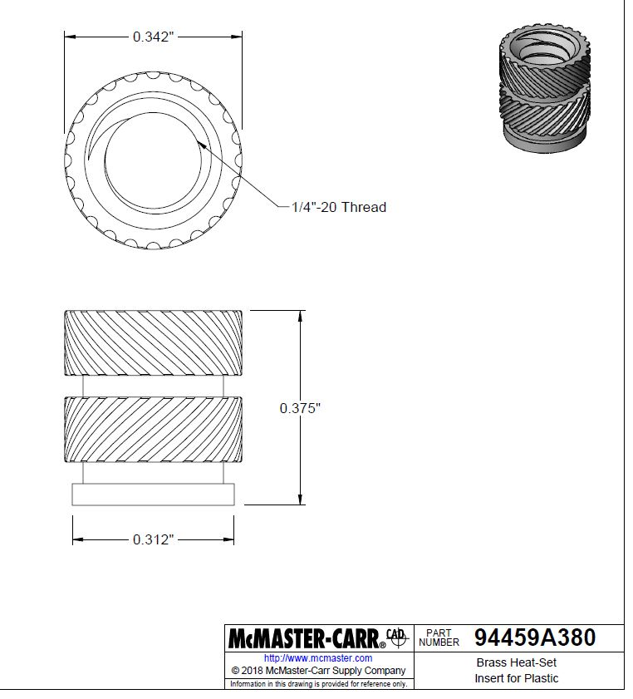

These are heated with a special solder installation tip and will melt the surrounding plastic. When harder they produce threads which are much better that trying to tap the plastic – but if over tightened the will pull through the plastic. The picture below is from a CAD model showing the parts inserted into a plastic part.

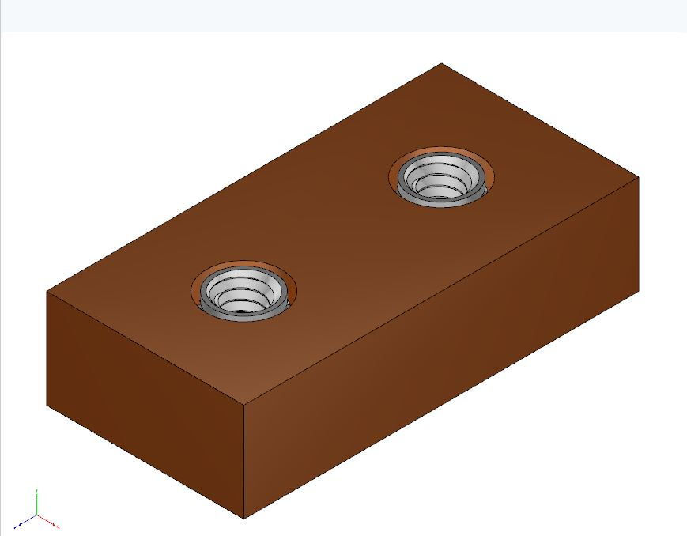

In Autodesk I built these holes by position two ‘points’ on the part and then using the hole feature to specify a counter bore:

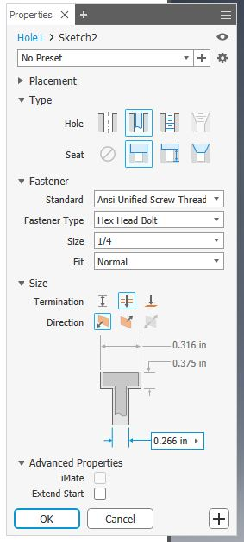

Here is the part drawing showing the dimensions for the insert:

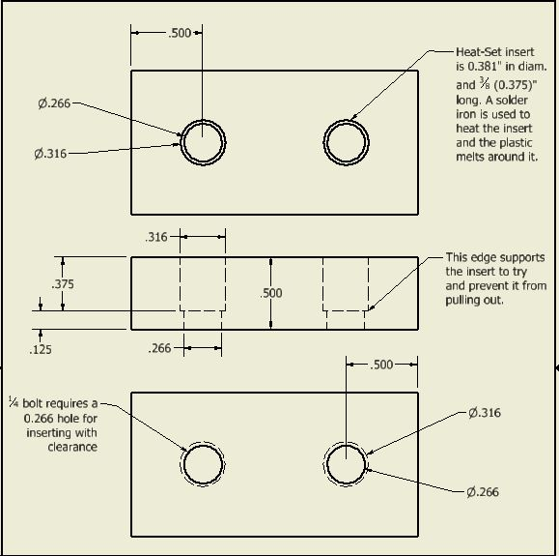

Here is a drawing showing the inserts in the part:

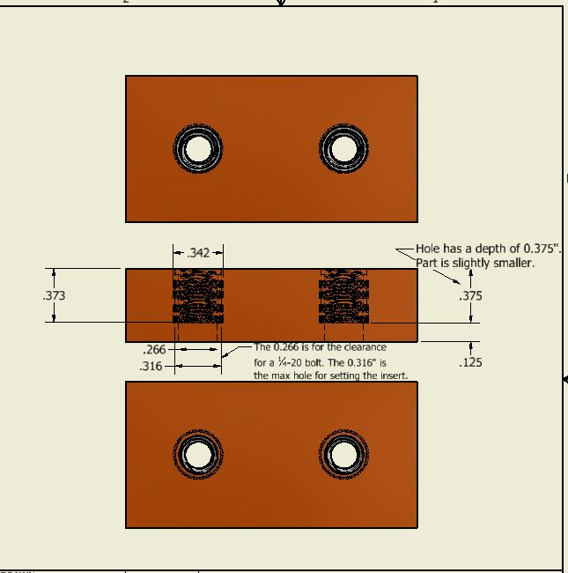

Here is a photo of an insert:

